柯文思：为何西方人难以理解中国故事？

柯文思 [这就是中国](javascript:void(0);)

**这就是中国**

微信号 mhshHome

功能介绍 东方卫视《这就是中国》节目官方账号 每周一晚22:00东方卫视播出

2021-11-10[原文](https://mp.weixin.qq.com/s?__biz=MzA5NTI5ODk3NA==&mid=2651174434&idx=1&sn=41e4793f1320de8fb4fe8a6a7342584e&chksm=8bb062d3bcc7ebc5b28e64cf4bf47c22864e370eff2799e97226072ef058204b118e3856882b&scene=27#wechat_redirect&cpage=7)

收录于话题

点击上方“蓝字”，发现更多精彩。

**让我们一起读懂中国，读懂世界**

谢谢，大家下午好！我来和大家讲讲我是如何来到中国的。

Thank you！Good afternoon everyone！Tell you a little  Story about  how I got here.

**奥斯卡金像奖获奖导演**

**柯文思为何独独迷恋中国？**

很多年前，当我在纽约开始在美国广播公司的新工作时，他们给了我一项令人兴奋的项目，拍一部关于中国是如何实现快速现代化的电影。对我来说，这是一个很大的机会，但我从来没细想过为什么？为什么是我？一个非常初级的电影制作人，被赋予如此重大的责任？直到后来，我才发现我的每一个美国同事，都拒绝了这个项目。因为没有人，对在一个不发达的第三世界共产主义国家旅行几个月感到兴奋。在记者、纪录片导演看来，去中国被认为是“艰苦的职责”。所以，我很幸运，我离开了纽约去探索这个复杂而迷人的神秘国家。

Many years ago when I was starting a new job in New York with the US TV network; ABC… I was offered an exciting assignment; to make a film about how China was rapidly entering the modern world. To me, this was a huge opportunity – and it never occurred to me to ask; why? Why was I – a very junior film-maker - being given this enormous responsibility? It was only later that I found out every one of my American colleagues had turned down the assignment - nobody was excited at the prospect of several months travelling around an underdeveloped, third-world, communist country. China was considered ‘hardship duty’. And so, I got lucky and left NY eager to explore all the mysteries of this complex and fascinating land.

几个月来，我走遍了中国，会见了各行各业的人。从四川的山村，到散布在长江和黄河岸边的社区。我不仅震惊于当地的贫穷和物资短缺，还被中国人民的坚忍、乐观和坚定不移的职业道德所打动，人们非常努力地工作。很明显，如果这些动力都能朝着一个清晰的愿景运作，这个国家将势不可挡。

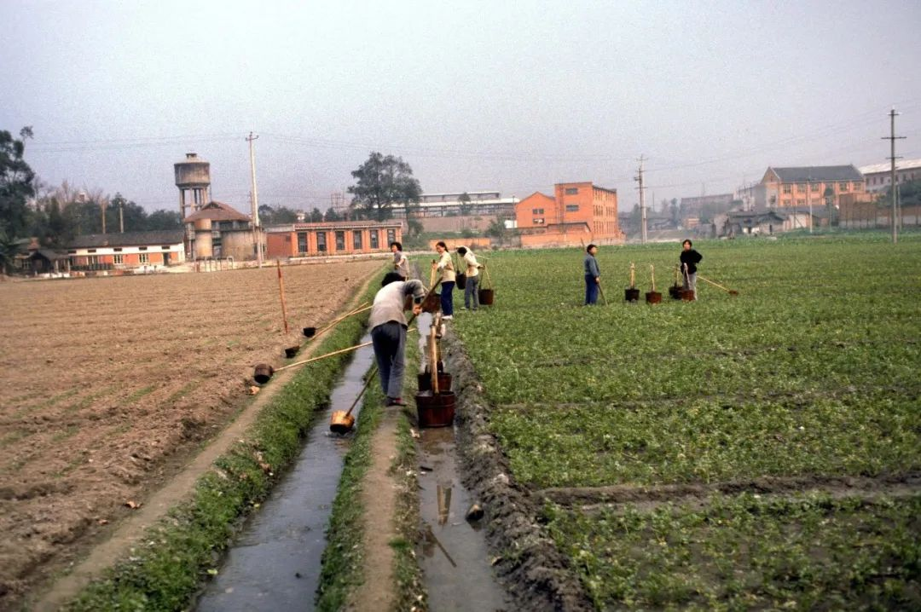

1980年12月，四川省成都市，村民正在灌溉田地。

图片作者:Marie Mathelin/Roger Viollet/Getty Images/视觉中国

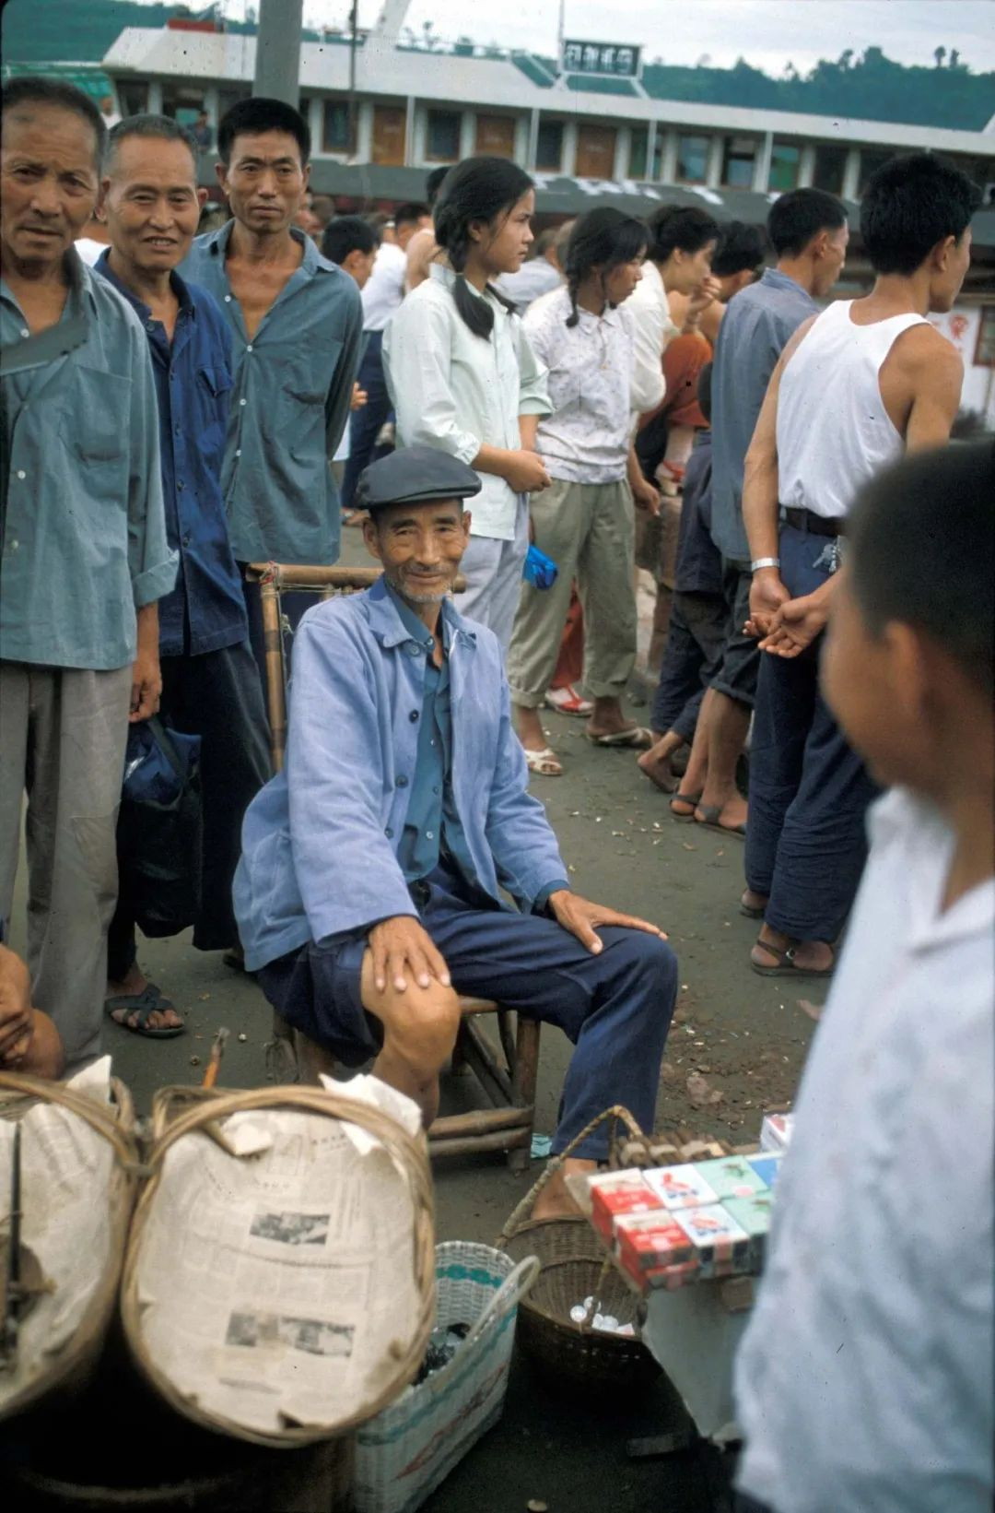

1980年代，四川省乐山市，熙熙攘攘的集市。

（图片作者:Marie Mathelin/Roger Viollet/Getty Images/视觉中国）

For months I journeyed the length and breadth of China meeting scores of people from all walks of life. From mountain villages in Szechuan, to communities scattered along the banks of the Yangtse & Yellow rivers. I was struck not only by the poverty and deprivation, but also by the stoicism, optimism and unwavering work ethic of the Chinese people. People worked tremendously hard. And it was clear that if all that energy could be harnessed with a clear vision - this country would be unstoppable.

那段旅程开启了我对中国和中国人民一生的迷恋。

That journey jump-started a lifelong fascination with China and its people.

**为何西方人**

**难以理解中国故事？**

三十年后我再次回到了中国，那是2013年，我已经认不出这个国家了。当然，那时一场非凡的复兴已经发生了，你们的国家正在成为全球超级大国。中国在国际社会中获得了应有的地位，它散发着自信和乐观。上世纪80年代我来的时候，看到了营养不良的儿童和真正物资匮乏。今天，中国每天养活14亿人口，这一成就只是中国改天换地的一个例子。中国可以也应该感到无比自豪，但世界的其它国家是否意识到了这些发展？我对此表示怀疑。

It was more than thirty years before I returned to China, and in 2013 this country was unrecognizable. By then of course, a remarkable renaissance had taken place and your country was becoming a global superpower. China claimed its rightful place amongst the community of nations and was radiating newfound confidence and optimism. Back in the 80s I saw malnourished children and genuine deprivation. Today, China feeds 1.4 billion people every day and that achievement is merely one of myriad ways in which China has transformed out of all recognition. China can and should be immensely proud – but is the rest of the world aware of these developments? I doubt it.

那这是为什么？当我思考中国与西方的关系时，我看到了一个根本性的困境：中国需要被世界其它国家更好地理解，但不知为何，真正的理解总是难以捉摸的，说实话，这个国家（中国）一直没有受到应得的赞赏和尊重。尽管现代通讯发达，我们西方人对这里发生的事情仍然知之甚少。当我们不理解某件事时，我们会害怕它。在地缘政治的世界里，几个世纪的灌输已经在数百万人的头脑中牢固地建立了“西方特殊论”的神话，我们对一个我们几乎无法理解的文明的恐惧，可能会使我们迅速犯下灾难性的错误。

So why is that? When I think about China’s relationship with the ‘West’ I see a fundamental dilemma; China needs to be better understood by the rest of the world, but somehow - real understanding is elusive; it never quite coalesces into the kind of appreciation and respect that this country deserves and has earned. Despite the sophistication of modern communications, we in the West still know so little of what’s going on here. And when we don’t understand something we tend to fear it. And in the world of geopolitics, where centuries of indoctrination have firmly established the myth of Western exceptionalism in the minds of millions, our fear of a civilization we barely comprehend could swiftly carry us all towards calamitous outcomes.

在过去的几年里，我把上海称为我的家。对我来说，中国的改革和复兴是本世纪最大的新闻。中国一直是社会学和技术奇迹的摇篮，所有这些都可以被做成引人入胜的电影故事。作为一个导演，我总是渴望发现独特的故事，中国就是那个不断提供灵感的礼物。

Over the past few years I’ve come to call Shanghai my home away from home. China's reform and renaissance is to me, the biggest news story of the century. Your country has been an incubator for both sociological and technological miracles – all of which can become the raw material of fascinating films. As a director always eager to discover unique stories, China is the gift that keeps on giving.

我很高兴听到张教授提到“数千万在网上发布照片、视频和故事的普通中国人”。这些融入了普通人日常生活中微小而迷人的生活片段的“迷你电影”，比无数国家赞助的节目更能打动人。

I was gratified to hear Professor Zhang refer to the “tens of millions ordinary Chinese folks who post photos, videos, and stories online” – for those ‘mini-films’; tiny, charming slice-of-life windows into the everyday experiences of ordinary people would do more to humanize this country than countless hours of state-sponsored programming.

**西方需要看到更多**

**中国普通人的故事而不是数据**

如果西方观众能看到更多，“中国诚实和真诚的日常生活”，人们偏见的转变将是迅速而有力的。我们越觉得“你们”和“我们”差不多，就越容易接受中国和中国人民。

If western audiences could see more “honest and sincere reflections of your daily lives”. The transformation in peoples’ prejudices would be swift and emphatic. The more we feel that ‘you guys’ are pretty much the same as ‘us guys’ – the easier it will be to accept China and its people.

随着阿富汗最近的变化，以及西方帝国国家建设计划的支离破碎，重新平衡中国与世界其它国家之间的“理解赤字”变得更加紧迫。

    With the recent fall of Afghanistan – and with the West’s imperial nation-building plans in tatters, it's become even more urgent to rebalance the 'understanding deficit' between China and the rest of the world.

 我并不天真，我不相信几部受欢迎的电影和老奶奶跳舞的网络帖子能化解西方对中国发动的 “宣传圣战”。但我坚信，对你认识和理解的人发动战争，要比对你不认识，感觉与你的价值观和原则格格不入的人发动战争困难得多。

Now, I’m not naïve and I don’t believe the answer to the appalling ‘propaganda jihad’ that’s being waged against China will be averted by a few favorable films and internet posts of charming dancing grannies. But I fervently believe it’s much harder to wage war against people you know and understand than against people you don’t know and feel are alien to your values and principles.

中国人觉得他们了解美国，是因为美国了解“大众文化”的力量。一个多世纪以来，美国通过各种媒介讲述他们的故事。他们用情感来讲述“美国经历” 所以这些故事能引起全世界观众的共鸣。我们从中国听到的很多东西似乎都集中在“成就”上；最大、最快、最高，来自“美丽中国”的各种技术进步，但没有人性的一面。为什么一个充满风土人情的国家，不讲人的故事？

Chinese people feel like they know America because America understands the power of 'Popular Culture.' For more than a century American stories have been told through every conceivable medium. Stories that resonate with audiences the world over because they use raw emotion above all else to tell tales of the ‘American Experience’. Much of what we hear from China seems to focus on ‘achievements’; the biggest, the fastest and tallest – all manner of technological advances from ‘Amazing China’ – but without a human dimension. Why no amazing people – from a country that is full of them?

**柯文思：**

**希望通过自己的努力**

**让西方世界了解中国**

几个月前，我执导了《柴米油盐之上》，一部中国“小康社会”的系列纪录片，为了全面建设小康社会，中国人民投入了大量资源、辛勤工作和善意，展现了这个国家是一个公平和有人情味的地方。

纪录片《柴米油盐之上》片段

导演：柯文思（英国)

每部电影讲了穷人的故事，他们的生活因趁着中国历史性的经济改革的浪潮而改变。这些故事本可以用深奥的政治概念、大量的事实和数字来讲述，但它们会感动我们的观众吗？可能不会。但是通过在普通老百姓中找主角，诚实和幽默地描述他们的生活和爱情，他们的成就、挣扎和失败，我们在世界各地都有欣赏这个作品的观众。

Several months ago, I directed ‘A Long Cherished Dream’ a series of short films about Xiaokang, which a huge amount of resources, hard work and goodwill was devoted to changing the tide of Chinese history - making the country a more equitable and humane place to live.  Each film tells the story of people born into poverty, whose lives were transformed by riding the wave of China’s historic economic renaissance. These stories could have been told using abstruse political concepts, with lots of facts and figures – but would they have inspired our audience? Probably not. But by putting a human face on our characters, describing their lives and loves, their achievements, struggles and failures - with honesty and humor – we managed to find an appreciative audience all around the world.

事实上，世界并不渴望关于中国的数据信息，我们已经被数据和统计数据压得喘不过气来，但我们渴望了解普通人的故事，让我们欣赏那些带来中国历史性转变的人们，他们日常的得失。

In truth, the world isn’t starved for factual information about China – we’re overloaded with data and statistics - but we’re hungry for human stories that can make us appreciate the every day victories and defeats of the people who brought about this historic Chinese transformation.

 我们越好地讲述这些故事，中国就越会开始感到自己受到尊重，或许还会受到钦佩。这也是我最希望的：让世界充分了解中国的成就。

And the better we tell those stories, the more China will begin to feel itself both respected and perhaps admired – and what I hope for the most; China will be understood for all that is has achieved.

我们的作品越是能够凸显中国人的价值观和人情，就越能向忧心忡忡的西方世界证明：中国的崛起并不意味着西方的衰退。通过这样做，也许我们可以尽自己的一份微薄之力来避免文明之间即将爆发冲突的战争言论。谢谢大家！

The more our work can capture the world’s imagination by highlighting the value and humanity of the Chinese people, the better we can demonstrate to an apprehensive world that the rise of China doesn’t mean the demise of the West. And by so doing – perhaps we can do our small part to avert war-mongering talk of an impending conflict between civilizations. Thank you！

（本节目播出于2021年11月08日）

**讲中国故事，讲我们的故事**

**东方卫视《这就是中国》**

**每周一晚22：00**

**点击下方名片关注公众号**

**解锁更多精彩内容**



### 精选留言

用户设置不下载评论